**Assignment 4**

|  |  |
| --- | --- |
| **Date** | 10 November 2022 |
| **Team ID** | PNT2022TMID05082 |
| **Project Name** | Inventory Management System |
| **Batch number** | B11-5A1E |

Docker and Kubernetes

1. **Pull an image from docker hub and run it in docker Playground**

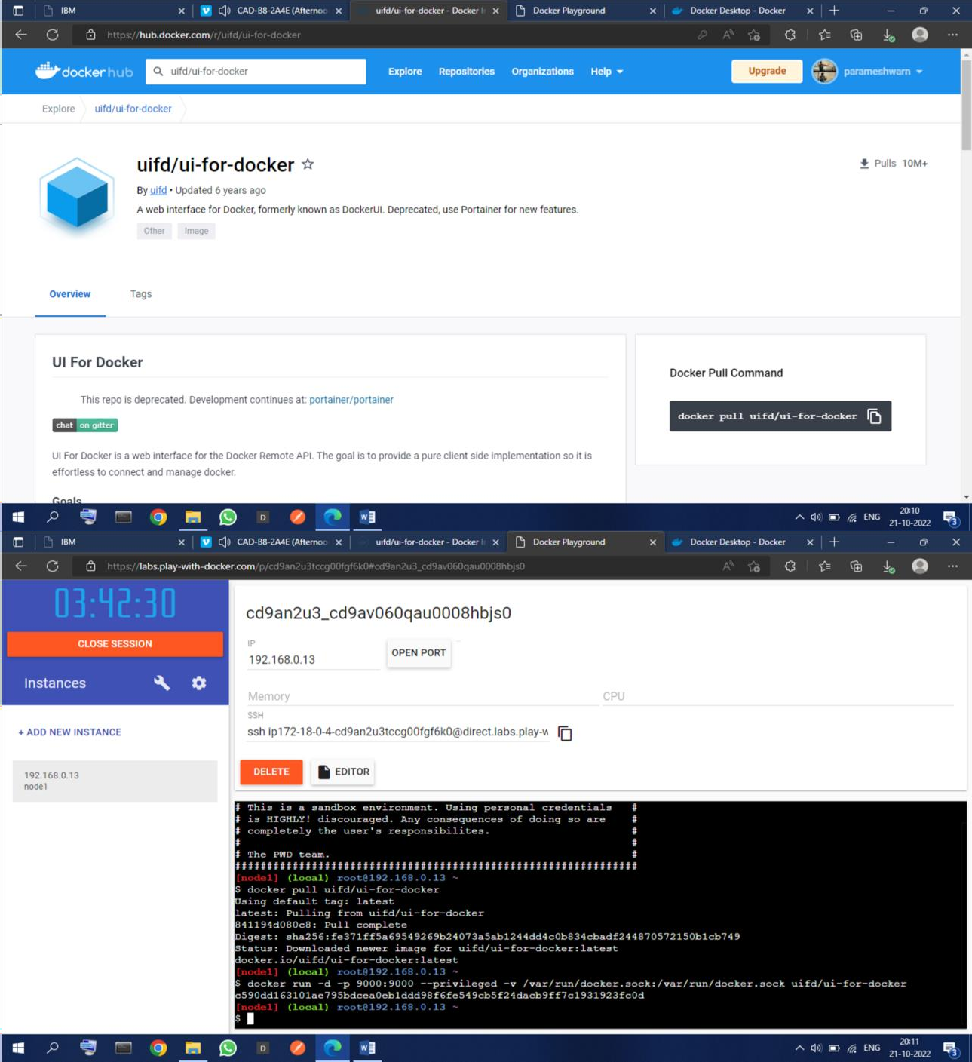

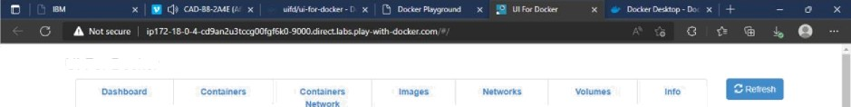

UI For Docker

UI For D-cker

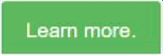The UI for Docker container engine

Running Containers Status

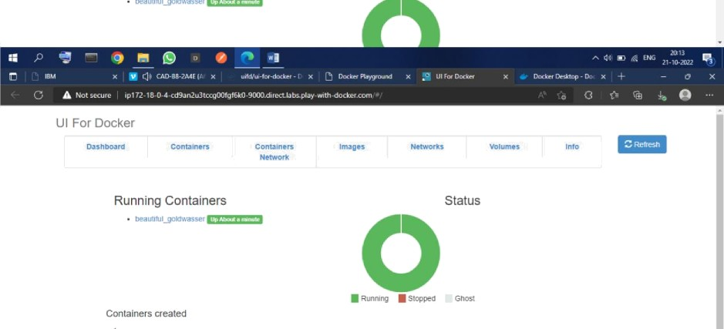

Images created



1. Create a docker file for the job portal application and deploy it in Docker desktop application

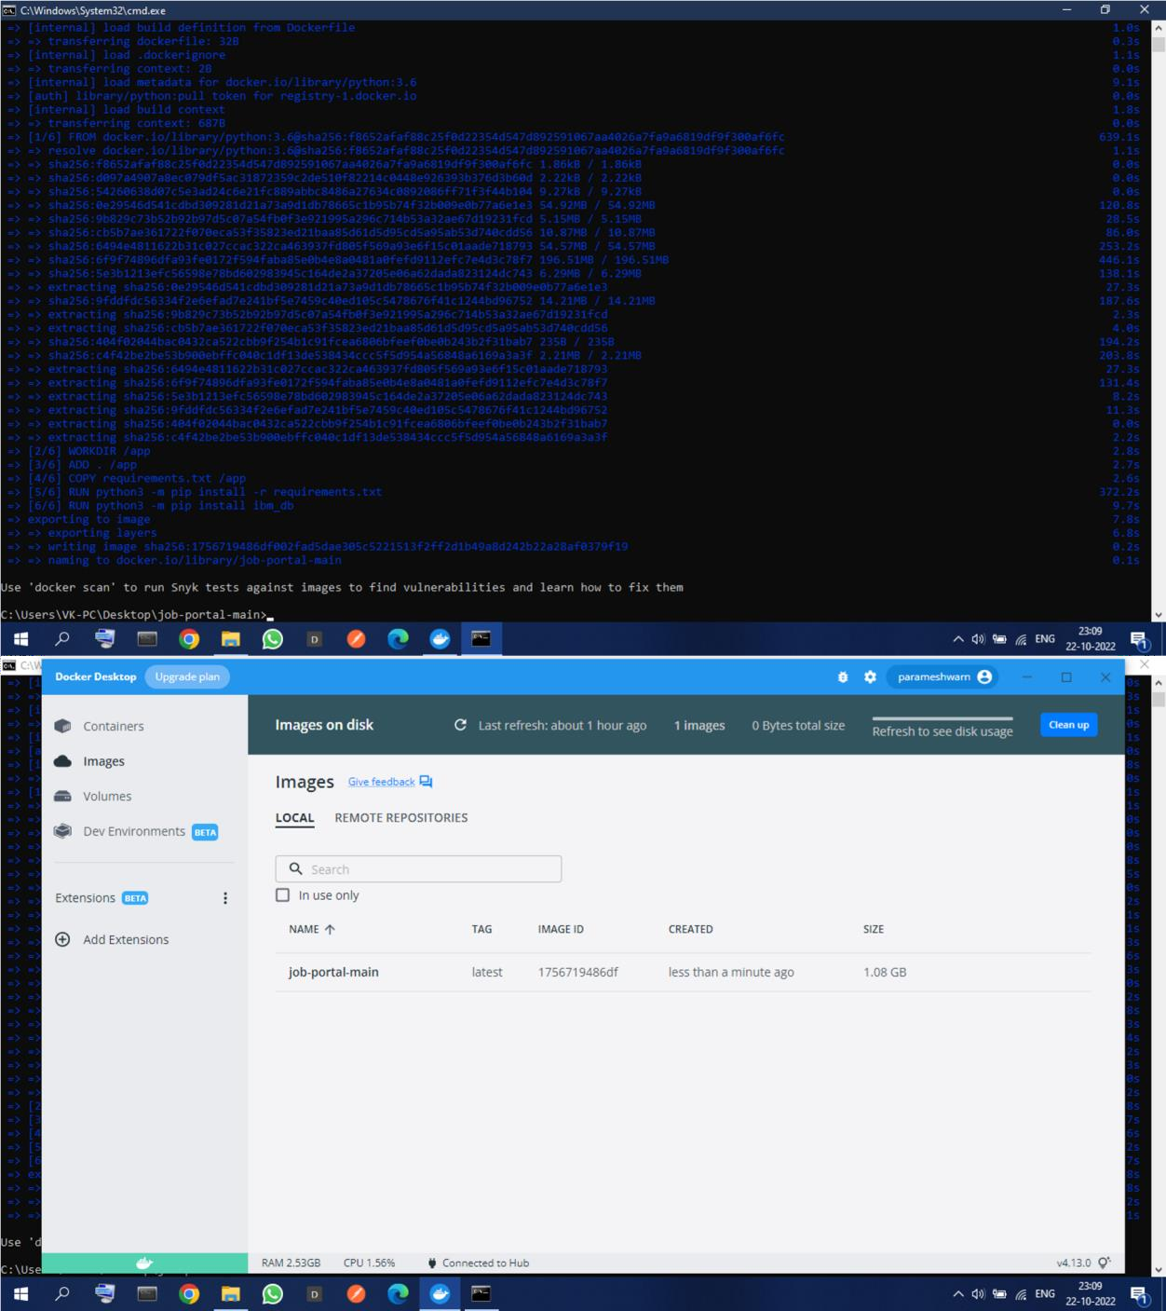

Question 3:

Create an IBM container registry and deploy helloworld app or job portal app.

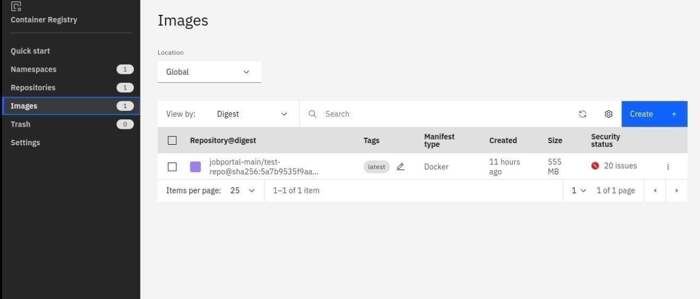

**Question 4:**

Create a kubernetes cluster in IBM cloud and deploy helloworld image or jobportal image and also expose the same app to run in nodeport.

apiVersion: v1 kind:

Service metadata: name: hello-world-

deployment spec: ports: - port:

5000 targetPort:

5000 selector: app: hello-world ---

apiVersion: apps/v1 kind: Deployment metadata: name: hello-

world- deployment spec:

replic as: 1 select or: matchLabels: app:

helloworld template: meta da ta :

la be ls : app:

hello- world spec:

containers:

* name: hello-world image: au.icr.io/hello-worldapp/helloworld imagePullPolicy: Always ports:
* containerPort: 5000

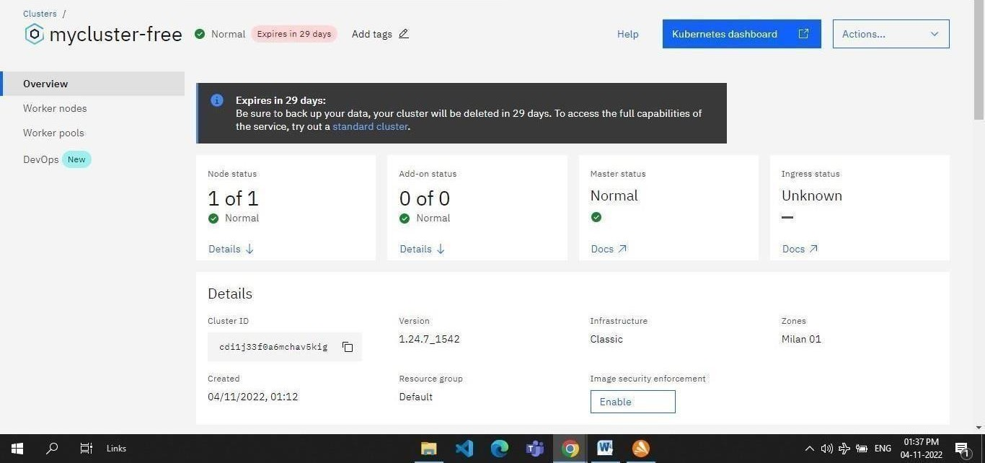

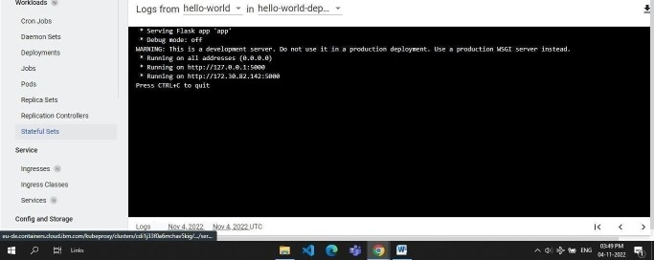*ku be r n et es * 

== worMoads › Pods › hello-world-deployment-6c75b9c898-g4nrv › Logs